**Spring Core Maven**

**Exercise 1: Configuring a Basic Spring Application**

**Step 1: Set Up a Spring Maven Project**

Created a Maven project named LibraryManagement.

Added Spring Core dependencies in the pom.xml file.

**Step 2: Added Spring Core Dependencies in pom.xml**

<dependencies>

<dependency>

<groupId>org.springframework</groupId>

<artifactId>spring-context</artifactId>

<version>5.3.31</version>

</dependency>

</dependencies>

Created an XML configuration file named applicationContext.xml in the src/main/resources directory.

Defined beans for BookService and BookRepository in the XML file.

**Step 3: Created XML Configuration File**

<?xml version="1.0" encoding="UTF-8"?>

<beans xmlns="http://www.springframework.org/schema/beans"

xmlns:xsi="http://www.w3.org/2001/XMLSchema-instance"

xsi:schemaLocation="http://www.springframework.org/schema/beans

https://www.springframework.org/schema/beans/spring-beans.xsd">

<bean id="bookRepository" class="com.library.repository.BookRepository" />

<bean id="bookService" class="com.library.service.BookService">

<property name="bookRepository" ref="bookRepository" />

</bean>

</beans>

**Step 4: Define Java Classes**

**Class: BookService.java**

**-> Created a package com.library.service and add a class BookService.**

**->Created a package com.library.repository and add a class BookRepository.**

package com.library.service;

import com.library.repository.BookRepository;

public class BookService {

private BookRepository bookRepository;

public void setBookRepository(BookRepository bookRepository) {

this.bookRepository = bookRepository;

} public void addBook(String name) {

System.out.println("Adding book: " + name);

bookRepository.saveBook(name);

}

}

**Class: MainApp.java (in package com.library)**

package com.library;

import com.library.service.BookService;

import org.springframework.context.ApplicationContext;

import org.springframework.context.support.ClassPathXmlApplicationContext;

public class MainApp {

public static void main(String[] args) {

ApplicationContext context = new ClassPathXmlApplicationContext("applicationContext.xml")BookService bookService = (BookService) context.getBean("bookService");

bookService.addBook("The Alchemist");}}

Output  
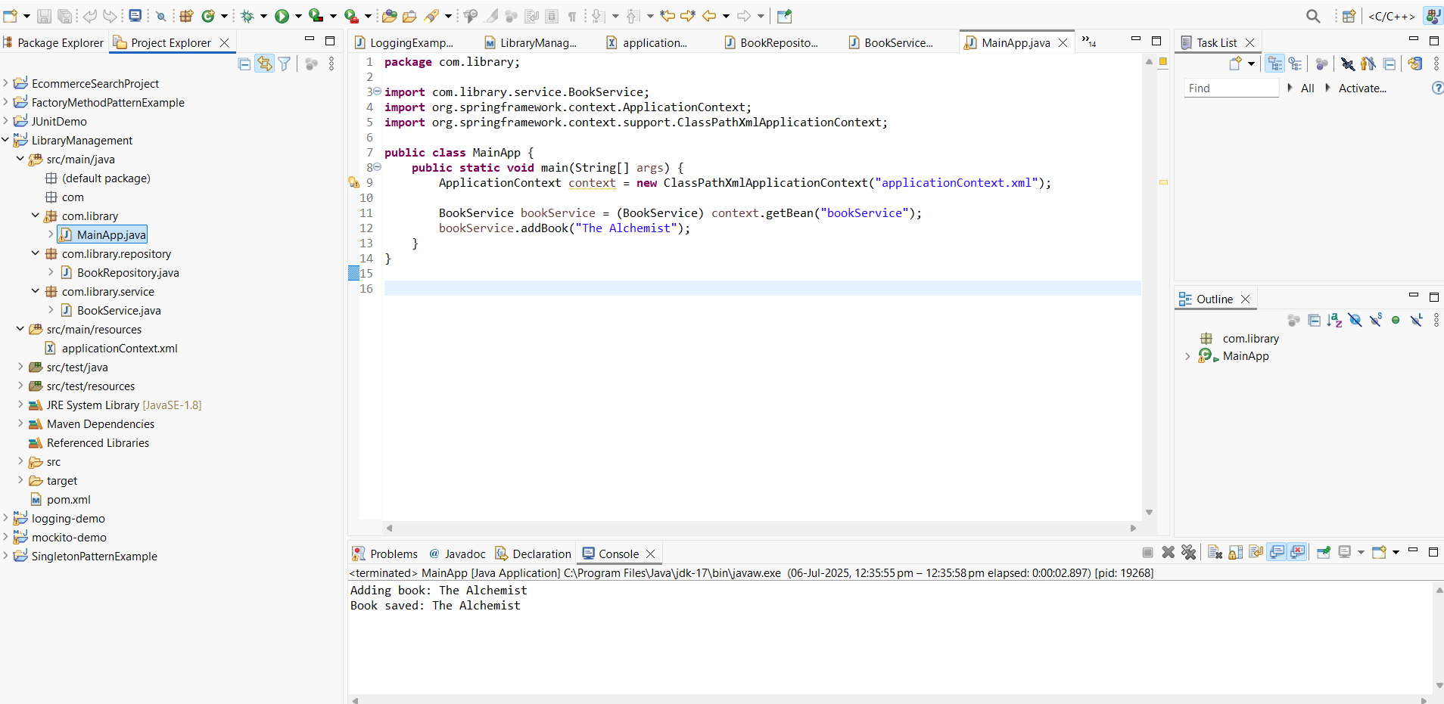

**Exercise 2: Implementing Dependency Injection**  
**Library Management Application - Spring Framework**

Step 1: Modify the XML Configuration

File: src/main/resources/applicationContext.xml

<?xml version="1.0" encoding="UTF-8"?>

<beans xmlns="http://www.springframework.org/schema/beans"

xmlns:xsi="http://www.w3.org/2001/XMLSchema-instance"

xsi:schemaLocation="

http://www.springframework.org/schema/beans

<https://www.springframework.org/schema/beans/spring-beans.xsd>"

<bean id="bookRepository" class="com.library.repository.BookRepository" />

<bean id="bookService" class="com.library.service.BookService">

<property name="bookRepository" ref="bookRepository" />

</bean>

</beans>

**Step 2: Update the BookService Class**

**File: src/main/java/com/library/service/BookService.java**

package com.library.service;

import com.library.repository.BookRepository;

public class BookService {

private BookRepository bookRepository;

public void setBookRepository(BookRepository bookRepository) {

this.bookRepository = bookRepository;

}

public void addBook(String bookName) {

System.out.println("Adding book: " + bookName);

bookRepository.saveBook(bookName);

}}

**Step 3: Test the Configuration**

package com.library;

import com.library.service.BookService;

import org.springframework.context.ApplicationContext;

import org.springframework.context.support.ClassPathXmlApplicationContext;

public class MainApp {

public static void main(String[] args) {

ApplicationContext context = new ClassPathXmlApplicationContext("applicationContext.xml");

BookService bookService = (BookService) context.getBean("bookService");

bookService.addBook("The Great Gatsby");

}

}

**Output**

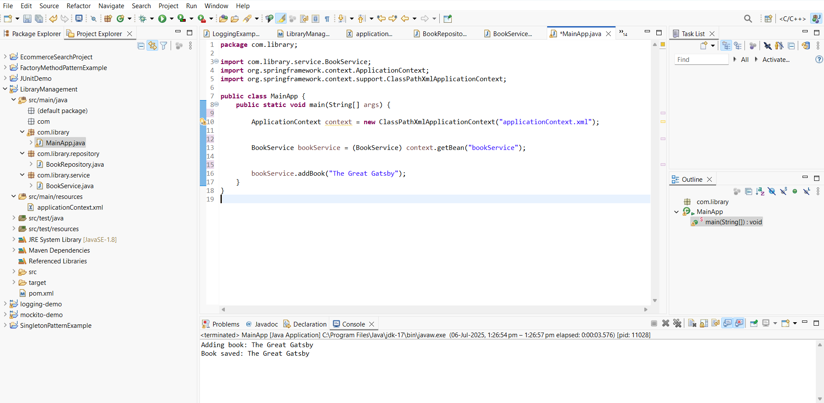

**Exercise 4: Creating and Configuring a Maven Project**

1. **Created a New Maven Project:**

**Group Id**: com.library

**Artifact Id**: LibraryManagement

**2. Add Spring Dependencies in pom.xml**

<dependencies>

<dependency>

<groupId>org.springframework</groupId>

<artifactId>spring-context</artifactId>

<version>5.3.31</version>

</dependency>

<dependency>

<groupId>org.springframework</groupId>

<artifactId>spring-aop</artifactId>

<version>5.3.31</version>

</dependency>

<dependency>

<groupId>org.springframework</groupId>

<artifactId>spring-webmvc</artifactId>

<version>5.3.31</version>

</dependency>

</dependencies>

**3. Configured Maven Plugins**

